# User Story Document: Full-Stack Food Delivery Website

Table of Contents

User Story Document: Full-Stack Food Delivery Website 1

**1. User Registration and Authentication** 3

**2. Browsing Restaurants and Menus** 4

3. Placing Orders 6

4. Payment Processing 8

5. Order Management 9

6. Customer Support 10

7. User Profile Management 10

8. Admin Panel 11

**User Stories**

# **1. User Registration and Authentication**

**User Story 1: Registration**

**As a new user**

* I want to register for an account.
* So that I can access personalized features like order history and saved preferences.

**Acceptance Criteria:**

* User can register with an email and password.
* Registration form includes fields for name, email, password, and confirm password.
* Users receive a confirmation email upon successful registration.

Fig 1: Images:

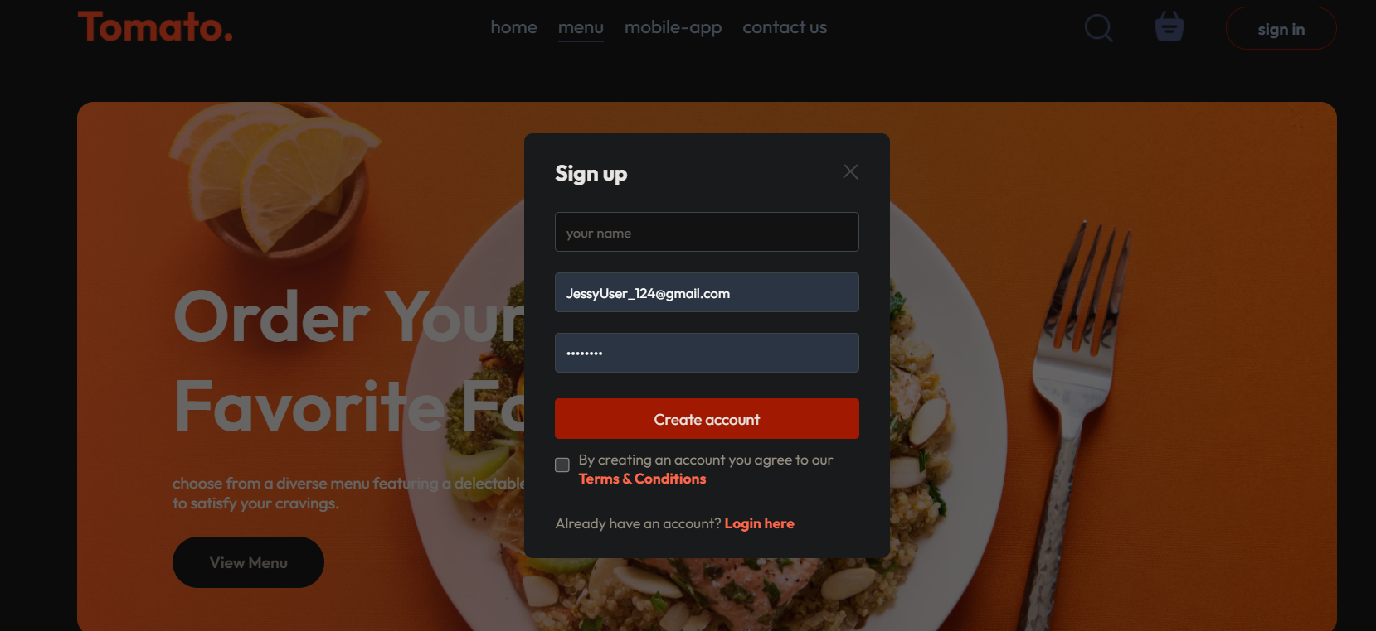

**User Story 2: Login**

* As a registered user.
* I want to log in to my account.
* So that I can access my profile and place orders.

**Acceptance Criteria:**

* User can log in with their registered email and password.
* Login form includes fields for email and password.
* Users receive an error message if login credentials are incorrect.

FIG: 2 image.

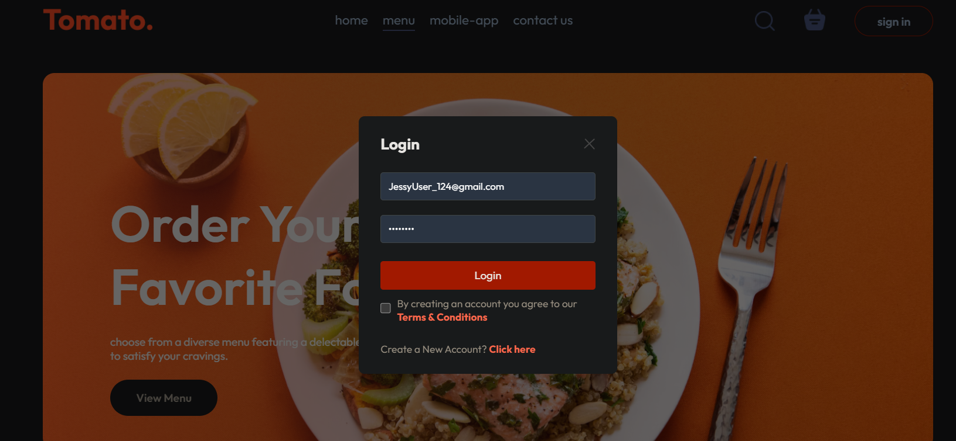

# **2. Browsing Restaurants and Menus**

**User Story 3: Browse Restaurants**

**As a user**

* I want to browse a list of local restaurants.
* So that I can choose a restaurant to order from

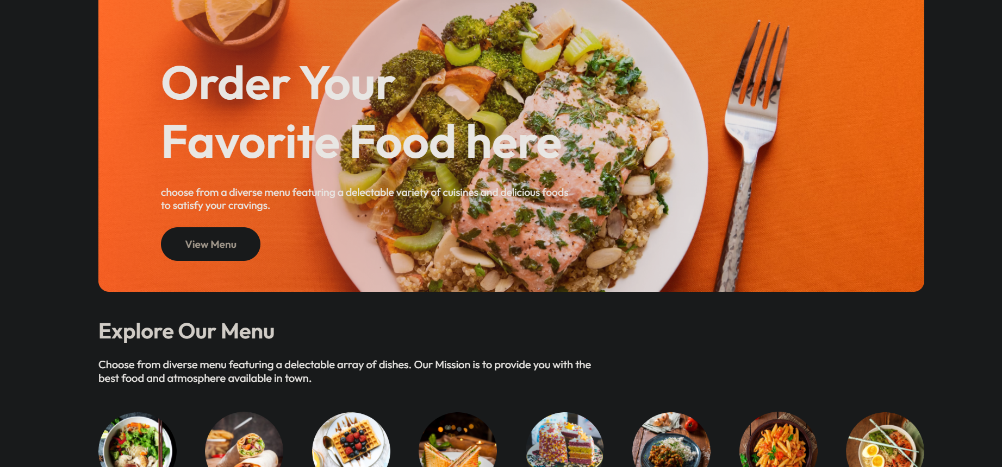

**Acceptance Criteria:**

* Users can view a list of restaurants with basic details (name, cuisine type, rating).
* Restaurants can be filtered by cuisine type, rating, or distance.

**User Story 4: View Menu**

* As a user.
* I want to view the menu of a selected restaurant.
* So that I can choose items to order.

**Acceptance Criteria:**

* Users can view a detailed menu with item names, descriptions, prices, and images.
* Users can see if an item is vegetarian, vegan, or gluten-free.

Fig 3 : images

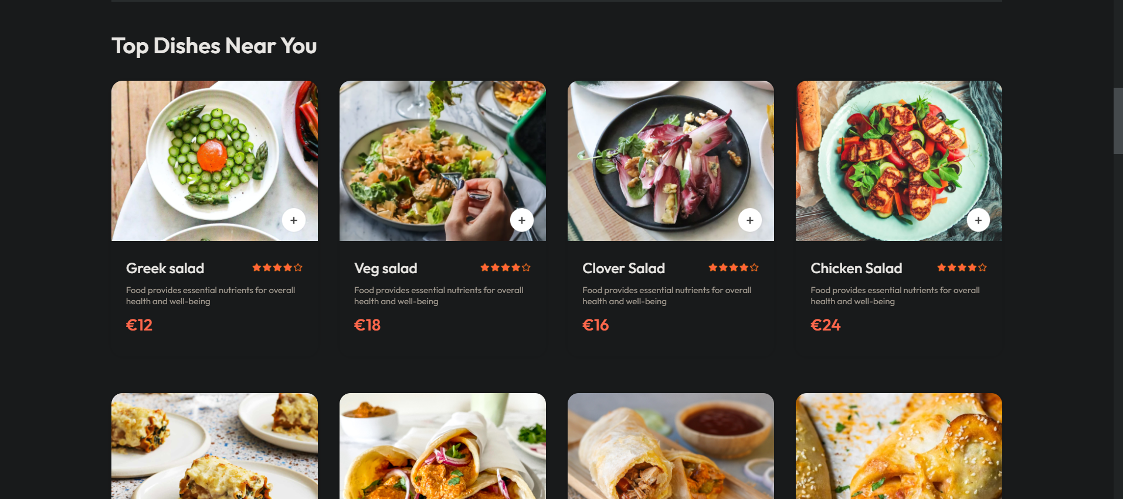

### 3. Placing Orders

**User Story 5: Add Items to Cart**

* **As a** user.
* **I want** to add menu items to my cart.
* **So that** I can review my order before checking out.

Fig 4: image

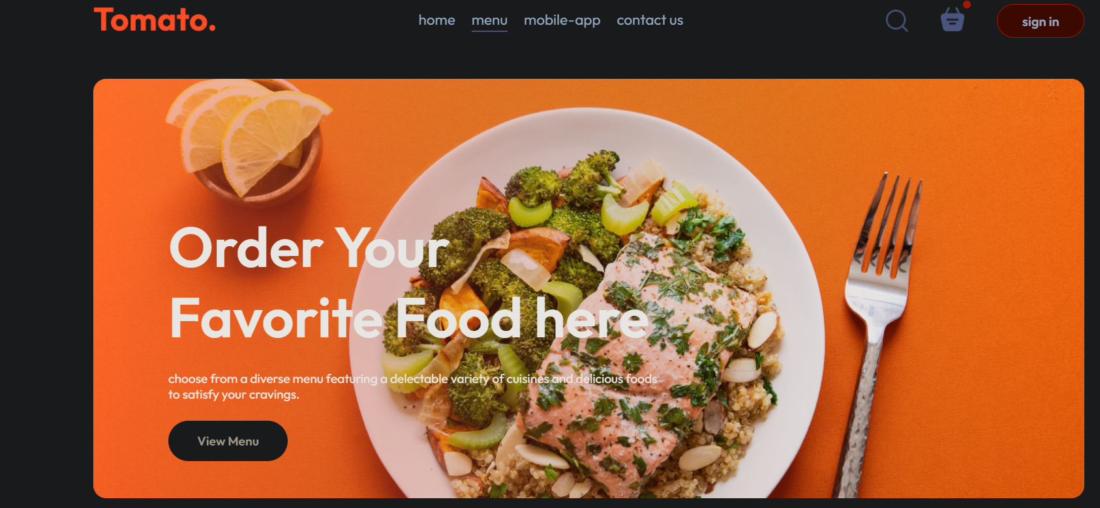

**Acceptance Criteria:**

* Users can add items to their cart with quantity options.
* Cart displays item names, quantities, individual prices, and total price.

Fig 5: image

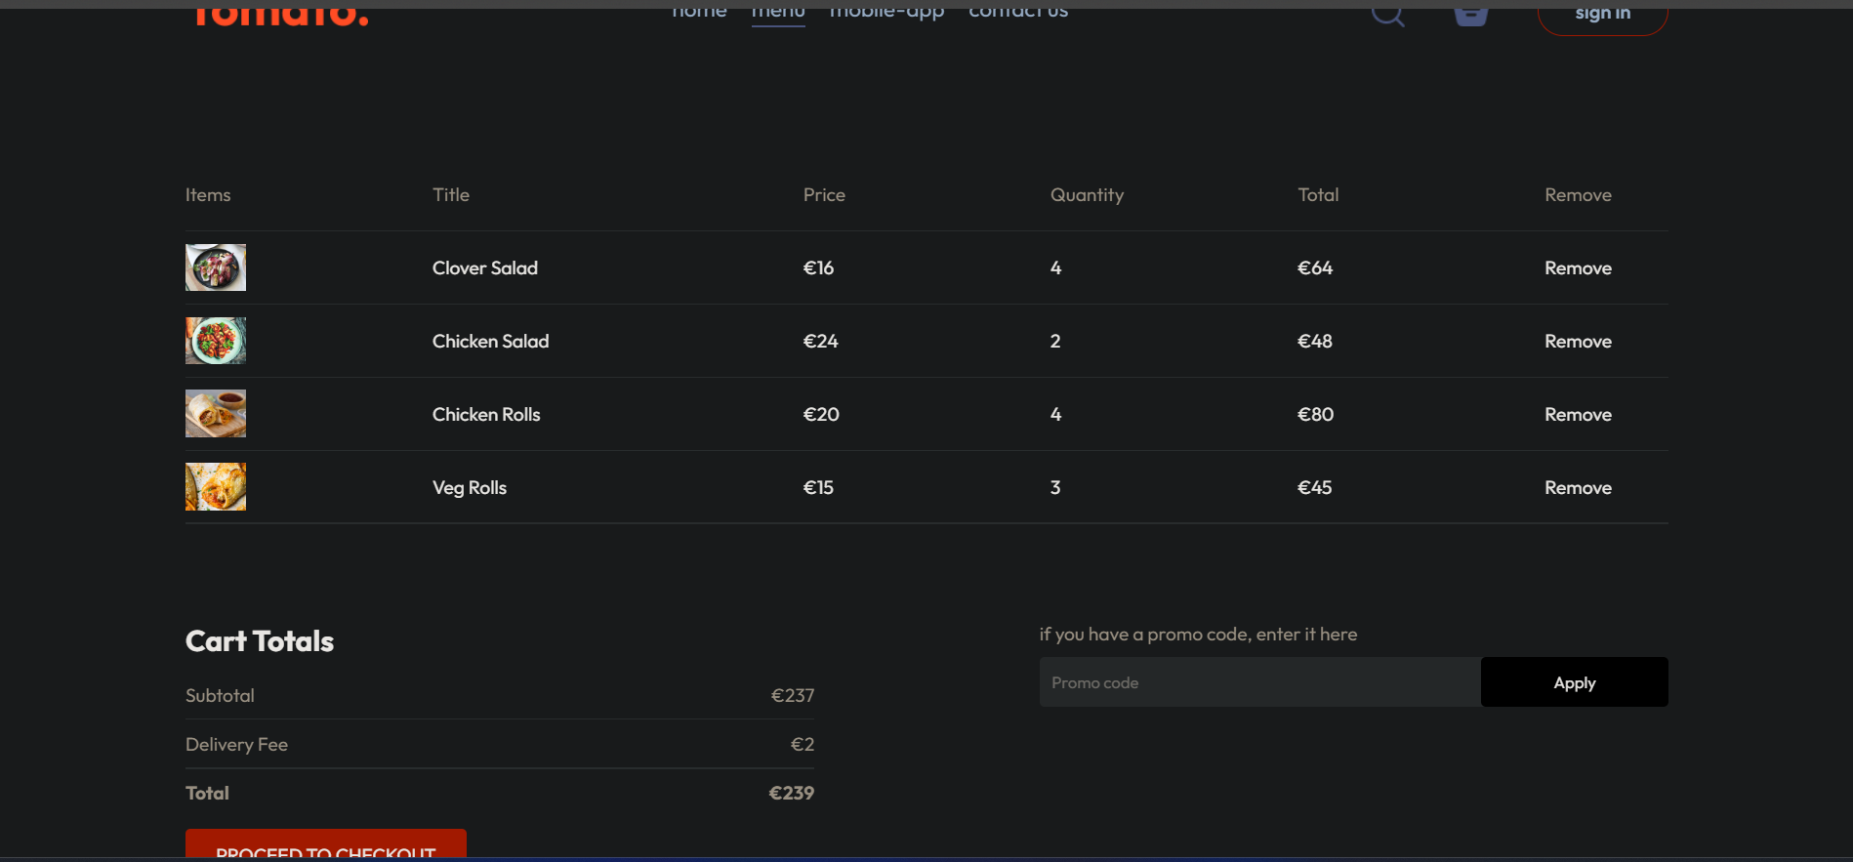

**User Story 6: Checkout**

* As a user.
* I want to proceed to checkout with my selected items.
* So that I can place my order.

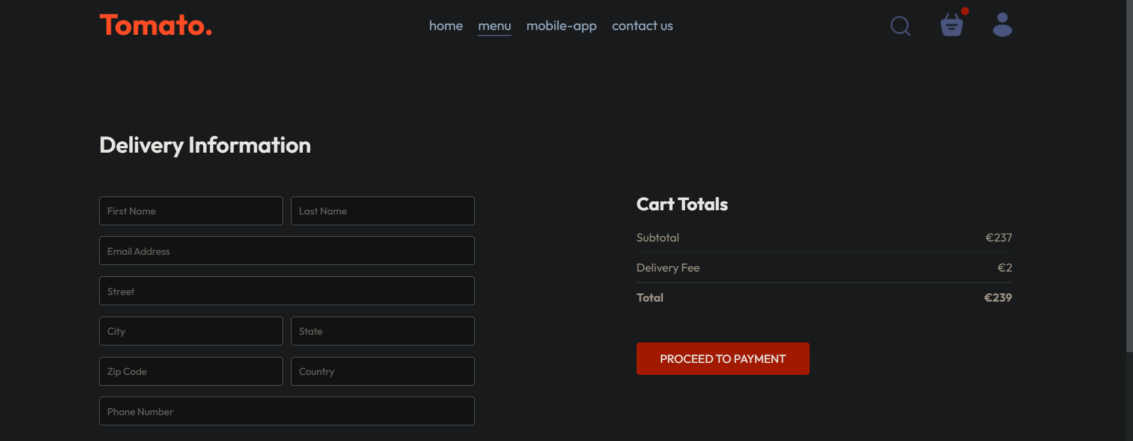

**Acceptance Criteria:**

* Users can review their order summary at checkout.
* Users can add delivery instructions and choose payment options.

# 4. Payment Processing

**User Story 7: Make Payment**

* As a user
* I want to make a secure payment for my order.
* So that I can complete my purchase.

**Acceptance Criteria:**

* Users can enter payment details securely (integrated with Stripe).
* Payment is processed securely, and users receive a confirmation message.

Fig: Image

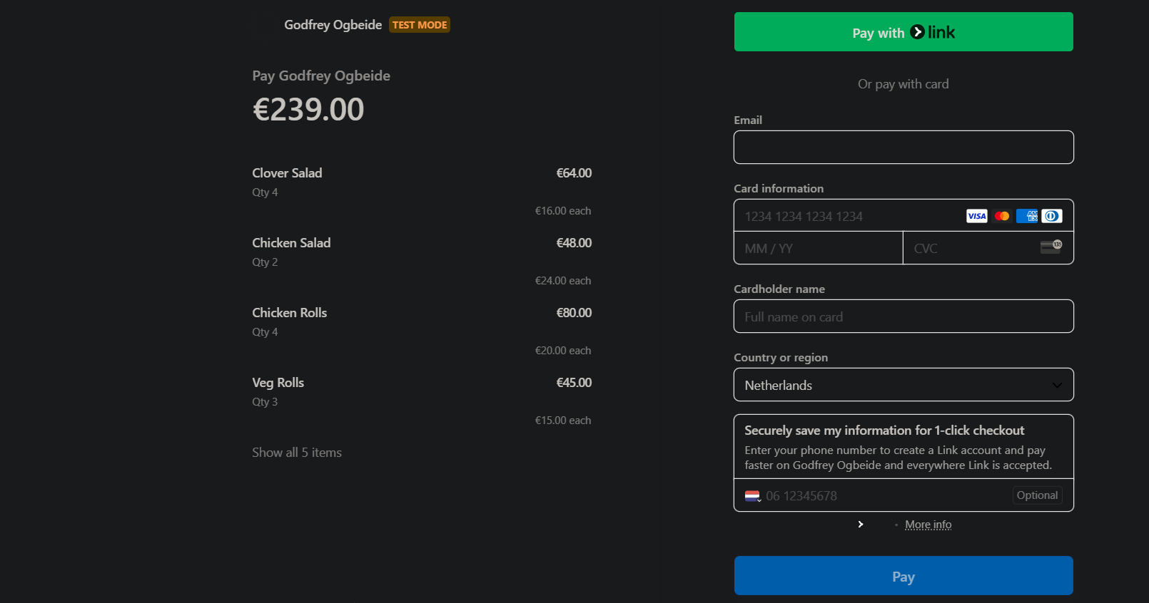

# 

# 5. Order Management

**User Story 8: Order History**

* As a user.
* I want to view my past orders.
* So that I can reorder easily if I liked a previous meal.

**Acceptance Criteria:**

* Users can view a list of past orders with details like order date, items, and total price.
* Users can reorder items from past orders.

**User Story 9: Track Order**

* As a user.
* I want to track the status of my current order.
* So that I know when to expect my delivery.

**Acceptance Criteria:**

* Users can see real-time updates on the status of their order (e.g., preparing, out for delivery, delivered).
* Users receive notifications when the status changes.

Fig 7: Image

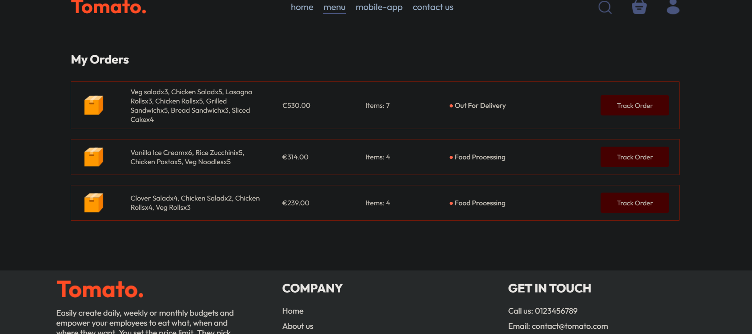

# 6. Customer Support

User Story 10: Contact Support

* As a user.
* I want to contact customer support.
* So that I can resolve any issues with my order.

**Acceptance Criteria:**

* Users can access a support form to submit their queries or issues.
* Users receive a confirmation that their support request has been received.

# 7. User Profile Management

**User Story 11: Update Profile**

* As a user.
* I want to update my profile information.
* So that my account details are always up to date.

**Acceptance Criteria:**

* Users can update their name, email, and password from their profile settings.
* Changes are saved and reflected immediately.

# 8. Admin Panel

**User Story 12: Manage Restaurants and Menus**

* As an admin.
* I want to add, edit, or remove restaurants and their menus.
* So that I can keep the platform updated with accurate information.

FIG 8 Images:

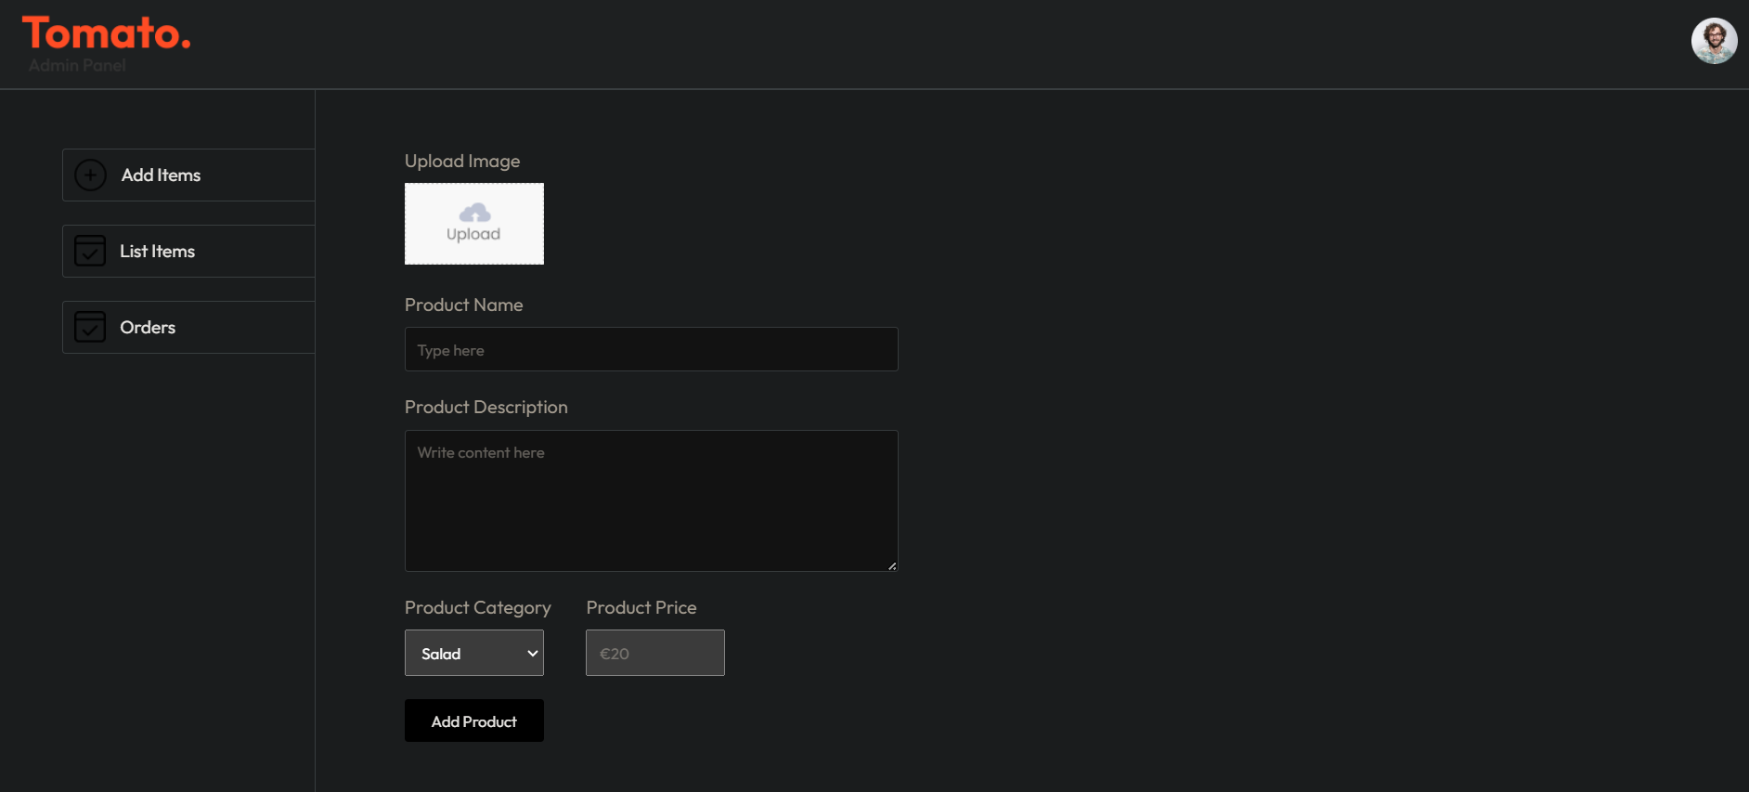

**Acceptance Criteria:**

* Admin can add new restaurants with details like name, cuisine type, and rating.
* Admin can edit existing restaurant details and update menus.
* Admin can remove restaurants and menu items that are no longer available.

FIG 9 Images:

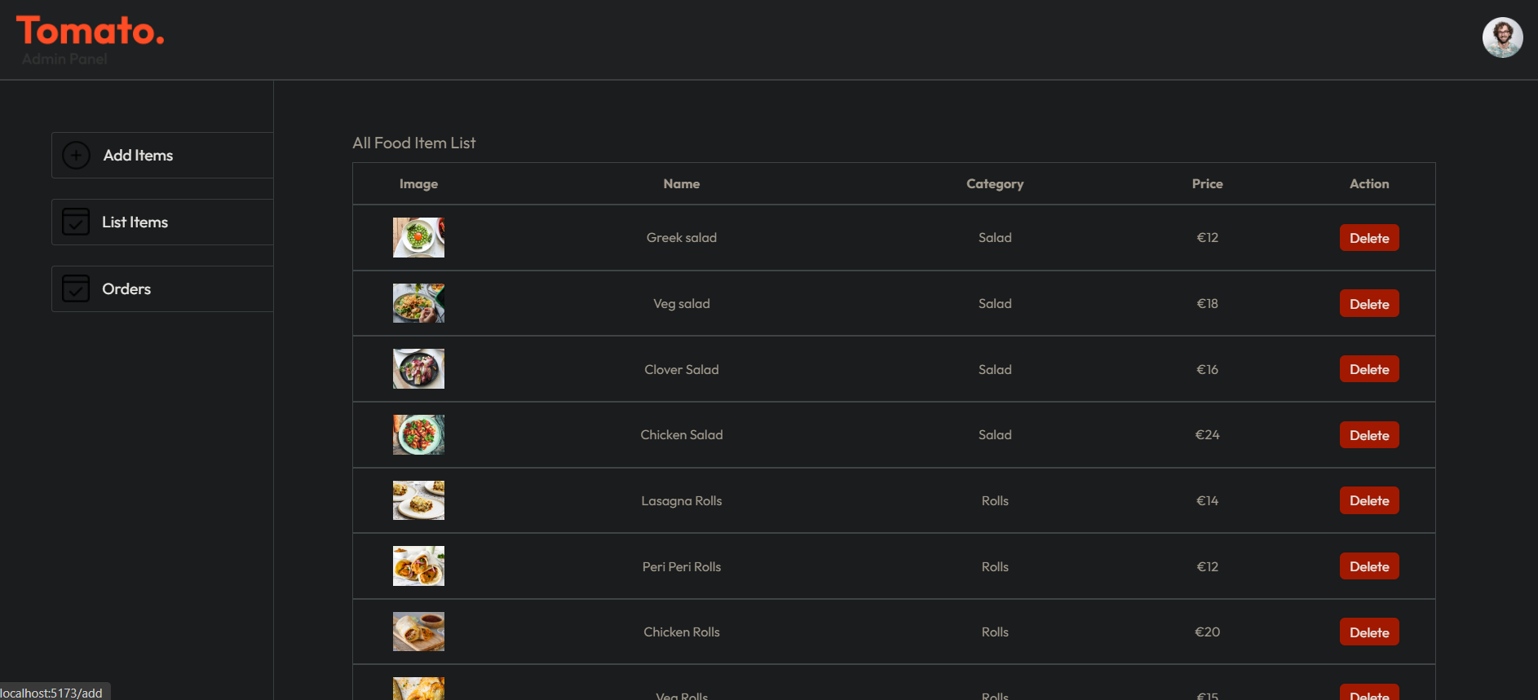

**User Story 13: Manage Orders**

* As an admin.
* I want to view and update the status of customer orders.
* So that I can ensure orders are processed and delivered efficiently.

**Acceptance Criteria:**

* Admin can view a list of all orders with details like customer name, order items, and status.
* Admin can update the status of orders (e.g., preparing, out for delivery, delivered).

**User Story 14: View User Activity**

* As an admin.
* I want to view user activity and order history.
* So that I can monitor the platform's performance and user engagement.

**Acceptance Criteria:**

* Admin can view a dashboard with metrics on user activity and order history.
* Admin can generate reports on user engagement and platform performance.

Fig 10 images:

